CHAPTER 1
INTRODUCTION
1.1 ABOUT THE PROJECT
Technology has brought as to a stage where a place for a firm in the information super high way has become necessary of its survival in the cooperate world. Sensing the urge of the companies to be present in the fast growing IT world every organization requires computerization.
The project “Restaurant Management System” help to keep about Restaurant activities include item code, item name, category, qty, total cost, price per item. The stock details include stock id, qty. The sales details include sale id, item price, qty and amount. The purchase details actually contain billing details, it include product name, qty, amount, full amount.
The project has been prepared based on Restaurant managements. All the details about the Restaurant are recorded in the database.
MD as the administrator of the Restaurant management system. MD can save, delete, update and check the stock and sales details in the Restaurant.

CHAPTER 2
SYSTEM STUDY AND PROBLEM FORMULATION
2.1 EXISTING SYSTEM
Analysis involves the requirement determination and specification. Basically it involves establishing requirements for all system elements and then mapping these requirements to the software form. The analysis is intended to capture and describe all the requirements of the system and to make a model that defines the key domain classes in the system. The purpose is to provide and understanding and to enable a communication about the system between the developers and the people establishing and requirements. Therefore the analysis is typically conducted in cooperation with the user or customer. The developer should not think in terms of code or programs during this phase; it is the first step towards really understanding the requirements.
This project work is concerned with developing a software Restaurant management system. System analysis was done in this context.
As well as all known earlier computer systems were store all data manually. It requires store all information about a snacks such as item name, manufacture id, qty, expiry date etc need too much space to store and also require more time to retrieve such information. The earlier computer systems are more time consuming to retrieve data. Such systems may not offer sufficient accuracy for data storing. These systems also difficult to manages. The main disadvantages of such systems with the data storing is there is a chance to store redundant data.
These systems are also difficult to manages. Because if we want to retrieve the details of medicine, we need to search different files until the particular items is found. So we can say that earlier computer systems are more time consuming to retrieve data.
2.2 PROBLEMS WITH THE EXISTING SYSTEM
Existing system is manual one. The main problems with the existing system are:
- More time consuming
- Lack of accuracy
- Not flexible
- Chance of data redundancy
- Searching process is very slow
- Less security
- Lack of data integrity

2.3 PROPOSED SYSTEM
The proposed system overcomes the limitations of an existing system. Using this System the user can retrieve useful information about the Restaurant system includes the details of items, stock, sales from different areas. The proposed system will offers more security to the data stored in the database. The proposed system is able to manage any large amount of data in its memory without any data redundancy and data losing. The major objective of computerization in any field is to make man’s job easier
2.4 FEATURES OF NEW SYSTEM
The advantages of using new system are:
- High efficiency
- Less time consuming
- Accuracy and security
- Provide GUI, user friendly
- Handle any amount of information
- Searching and retrieval of information is easy
- Reliable and flexible
.
2.5 FEASIBILITY STUDY
Feasibility is the determination of whether or not a project is worth doing. The process followed in making this determination is called a feasibility study. . The results of this study are used to make a decision whether or not to proceed with the project. If it indeed leads to a project being approved, it will — before the real work of the proposed project starts and be used to ascertain the likelihood of the project's success. It is an analysis of possible alternative solutions to a problem and a recommendation on the best alternative.
Once it has been determined that a project is feasible, the analyst can go ahead and prepare the project specification which finalizes project requirements. System feasibility is a test or evaluation of the complete system plan. Such an evaluation is necessary to define the application area along with its extends and complexity, to provide the scope of computerization together with suggested output and input format and potential benefits. The system study has to examine whether a technically feasible solution is possible.
Important tests of feasibility are studied and described below:
2.5.1 Technical Feasibility
There are a number of technical issues, which are generally raised during the feasibility stage of the investigation. It is a study of functions, performance and constraints that may affect the ability to achieve an acceptable system. The considerations that are normally associated technical feasibility include:
- Development Risk
- Resource Availability
- Technology
2.5.2 Economic Feasibility
Economic feasibility is an important task of system analysis. A system that can be developed technically and that will be used if installed must still be profitable for the organization. Financial benefits must equal or exceed the costs. The analysis raises financial and economic questions during the preliminary investigation to estimate the following:
- The cost to conduct a full systems investigation
- The cost of hardware and software.
- The benefits in the form of reduced costs or fewer costly errors.
- The project is economic feasible if the financial benefits exceed the cost.
To be judged feasible, a proposal for the specific project must pass all these tests, otherwise it is not considered as a feasible project.
2.5.3 Operational Feasibility
Proposed project is beneficial if only if they can be turned into information systems that will meet the operating requirements of the organization. This test of feasibility asks if the system will work when it is developed and installed. This project satisfies all the operational conditions. The system will be of great use if it is developed and implemented. The response of the employee will be encouraging as well as that of the users. When the system will implement the organization has several profits in their time.

CHAPTER 3
SYSTEM SPECIFICATION
3.1 HARDWARE SPECIFICATION
Processor : Pentium IV
Speed : 800MHZ
RAM : 256MB
Hard disk : 40GB
Monitor : 15’’SVGA color monitor
Keyboard : Enhanced 104 Standard
Mouse : 3 Button Scroll Mouse
3.2 SOFTWARE SPECIFICATION
Operating system: Windows 7 and Above
Front End : HTML
Back End : PHP
Database : MySQL
Browser : Internet Explorer 6.0, Google chrome
Other Requirement: Microsoft Word 2010, Macromedia dreamweaver

3.3 SELECTION OF SOFTWARE
A general set of engineering characteristics for a programming language can be established. They include ease of translation from design to code, computer efficiency, source code portability, availability of development tools and maintainability. The art of choosing a language is to start with the problem, decide what it requires and their relative importance since it will probably be impossible to satisfy all of them equally. Available languages should be measured against a lot of requirements.
The criteria that are applied during an evaluation of available languages are:
  - General Application Area
  - Environment in which software will execute
  - Performance consideration
  - Data structure complexity
All the above requirements are considered while choosing the programming language for the project inventory control system. It is developed using VB 6.0
PHP

Visual Basic is a third-generation event-driven programming language and integrated development environment (IDE) from Microsoft for its Component Object Model (COM) programming model first released in 1991 and declared legacy in 2008.Microsoft intended Visual Basic to be relatively easy to learn and use. Visual Basic was derived from BASIC, a user-friendly programming language designed for beginners, and it enables the rapid application development (RAD) of graphical user interface (GUI) applications, access to databases using Data Access Objects, Remote Data Objects, or ActiveX Data Objects, and creation of ActiveX controls and objects.
Visual Basic enables programmers can create both simple and complex GUI applications. Programming in VB is a combination of visually arranging components or controls on a form, specifying attributes and actions for those components, and writing additional lines of code for more functionality. Since VB defines default attributes and actions for the components, a programmer can develop a simple program without writing much code. Programs built with earlier versions suffered performance problems, but faster computers and native code compilation has made this less of an issue. VB programs can be compiled into native code executables from version 5 on; they still require the presence of around 1 MB of runtime libraries. Core runtime libraries are included by default in Windows 2000 and later, but extended runtime components still have to be installed. Earlier versions of Windows (95/98/NT) require that the runtime libraries be distributed with the executable.
Forms are created using drag-and-drop techniques. A tool is used to place controls (e.g., text boxes, buttons, etc.) on the form. Controls have attributes and event handlers associated with them. Default values are provided when the control is created, but may be changed by the programmer. Many attribute values can be modified during run time based on user actions or changes in the environment, providing a dynamic application. For example, code can be inserted into the form resize event handler to reposition a control so that it remains centered on the form, expands to fill up the form, etc. By inserting code into the event handler for a key press in a text box, the program can automatically translate the case of the text being entered, or even prevent certain characters from being inserted.
Visual Basic can create executables (EXE files), ActiveX controls, or DLL files, but is primarily used to develop windows application and to interface database systems. Dialog boxes with less functionality can be used provide pop-up capabilities. Controls provide the basic functionality of the application, while programmers can insert additional logic within the appropriate event handlers. For example, a drop-down combination box automatically displays a list. When the user selects an element, an event handler is called that executes code that the programmer created to perform the action for that list item. Alternatively, a Visual Basic component can have no user interface, and instead provide ActiveX objects to other programs via Component Object Model (COM).This allows for server-side processing or an add-in module.
The runtime recovers unused memory using reference counting, which depends on variables passing out of scope or being set to nothing, avoiding the problem of money leaks that are possible in other language. There is a large library of utility objects, and the language provides basic support for object-oriented programming. Unlike many other programming languages, Visual basic is generally not case sensitive-keywords into a standard case configuration and forces the case of variable names to conform to the case of the entry in the symbol table. String comparisons are case sensitive by default. The Visual Basic compiler is shared with other Visual Basic Studio languages (C, C++).Novertheless, by default the restrictions in the IDE do not allow creation of some targets (Windows model DLLs) and threading models, but over the years, developers have bypassed these restrictions.
FEATURES
- There are no line numbers as in earlier BASIC; code is grouped into subroutines or methods: Sub...End Sub.
- Code Statements have no terminating character other than a line ending.
- Statements used to terminate with keywords, such as “End If”, instead of using “{}”s to group statements.
- Logical and bitwise operators are unified. This is unlike some C-derived languages (such as Perl), which have separate logical and bitwise operators. This again is a traditional feature of BASIC.
- Relatively strong integration with the Windows operating system and the Component Object Model. The native types for strings and arrays are dedicated COM types, BSTR and SAFEARRAY.
- By default, if a variable has not been declared or if no type declaration character is specified, the variable is of type Variant.
- Integers are automatically promoted to reals in expressions that involve the normal division operator (/) so that division of one integer by another produces the intuitively correct result. VB provides a specific integer divide operator (\) that does truncate.
MySQL
In this mode, the state variables are stored in a database server, accessible using SQL. Session variables can be persisted across ASP.NET process shutdowns in this mode as well. The main advantage of this mode is it would allow the application to balance load on a server cluster while sharing sessions between servers.
Categories of types:
- Memory: data is stored on the stack
- Store the data
- Each variable gets its own place in memory
The .NET Framework is such a comprehensive platform that it can be a little difficult to describe. I have heard it described as a development platform, an execution environment, and an operating system among other things. In fact, in some ways each of these descriptions is accurate, if not sufficiently precise.
The software industry has become much more complex since the introduction of the Internet. Users have become both more sophisticated and less sophisticated at the same time. (I suspect not many individual users have undergone both metamorphoses but as a body of users this has certainly happened). Folks who had never touched a computer less than five years ago are now comfortably including the Internet in their daily lives. Meanwhile, the technophile or professional computer user has become much more advanced, as have their expectations from software.
It is this collective expectation from software that drives our industry. Each time a software developer creates a successful new idea, they raise user expectations for the next new feature. In a way this has been true for years. But now software developers face the added challenge of addressing the Internet and Internet-users in many applications that in the past were largely unconnected.
Features of SQL server
- CLR (Common Language Runtime)
- T-SQL (Transaction SQL) enhancements
- Service Broker
- Data encryption
- 5.SMTP mail
- 6.HTTP endpoints
- 7.Multiple Active Result Sets (MARS)
- 8.Dedicated administrator connection
- 9.SQL Server Integration Services (SSIS)
- 10.Database mirroring
Microsoft SQL Server 2005 includes a component named SQL CLR via which it integrates with .NET Framework. Unlike most other applications that use .NET Framework, SQL Server itself hosts the .NET Framework runtime, i.e., memory; threading and resource management requirements of .NET Framework are satisfied by SQLOS itself, rather than the underlying Windows operating system. SQLOS provides deadlock detection and resolution services for .NET code as well.
With SQL CLR, stored procedures and triggers can be written in any managed .NET language, including C# and VB.NET. Managed code can also be used to define UDTs which can be persisted in the database. Managed code is compiled to .NET assemblies and after being verified for type safety, registered at the database. After that, they can be invoked like any other procedure. However, only a subset of the Base Class Library is available, when running code under SQL CLR. Most APIs relating to user interface functionality are not available.
When writing code for SQL CLR, data stored in SQL Server databases can be accessed using the ADO.NET APIs like any other managed application that accesses SQL Server data. However, doing that creates a new database session, different from the one in which the code is executing. To avoid this, SQL Server provides some enhancements to the ADO.NET provider that allows the connection to be redirected to the same session which already hosts the running code. Such connections are called context connections and are set by setting context connection parameter to true in the connection string.
SQL Server also provides several other enhancements to the ADO.NET API, including classes to work with tabular data or a single row of data as well as classes to work with internal metadata about the data stored in the database. It also provides access to the XML features in SQL Server, including XQuery support. These enhancements are also available in T-SQL Procedures in consequence of the introduction of the new XML Data type
Apache Server
Internet Information Services (IIS) 6.0 is a powerful Web server that provides a highly reliable, manageable, and scalable Web application infrastructure for all versions of Windows Server 2003.IIS helps organizations increase Web site and application availability while lowering system administration costs. IIS 6.0 supports the Microsoft Dynamic Systems Initiative (DSI) with automated health monitoring, process isolation, and improved management capabilities.
Benefits
IIS 6.0 can increase the reliability of our Web infrastructure, reduce our total cost of ownership through easier server management and server consolidation, increase the security of our information systems, and deliver a platform for improved developer productivity.
- Increased Web server reliability and availability: IIS 6.0 features a new, fault-tolerant architecture with health monitoring and process recycling that significantly increases the reliability of our Web server infrastructure. IIS 6.0 ensures that one application's problems don't cause another application, or the server itself, to fail. These features increase the availability of our Web sites and applications and can reduce the time administrators spend managing these applications.
- Easier server management: IIS 6.0 features many new management tools designed to reduce the amount of time it takes to manage our Web server infrastructure. These features include a plain text XML configuration file that can be modified without having to stop the server, and command-line scripting. With these features, IIS 6.0 can increase the number of servers that a single administrator can manage.
- Server consolidation: IIS 6.0 is a highly-scalable Web server that provides new opportunities for Web server consolidation. By combining a reliable architecture with kernel-mode cache performance, IIS 6.0 enables more applications to be hosted on a single server. Server consolidation can reduce staffing costs, hardware costs, and site management costs.
- Faster application development: IIS 6.0 provides significantly improved security for Web servers. IIS 6.0 is locked down by default, limiting the attack surface area through aggressive security defaults. In addition, authentication and authorization have been improved. IIS 6.0 also provides increased management capabilities, improved administration with the XML metabase, and new command-line tools. IIS 6.0 can increase the security of our information systems while decreasing system management costs.

CHAPTER 4
SYSTEM DEVELOPMENT
System design involves translating information requirements and conceptual design into technical specification and general flow of processing. After the user requirements are identified, related information is gathered to verify the problem and after evaluating the existing system, a new system is proposed. The proposed system consists of various tables, their maintenance and report generation.

For the Design of Restaurant Management System care has been given for developing an efficient system, which is user friendly as well as high in performance. It has been assured that the system will have the functions and promises of the proposed system. In the design, the various techniques are used to present a simple efficient system. Design phase acts as a bridge between the software requirement specification and the implementation phase, which satisfies the requirements.

The data flow diagrams explicitly specify the process flow. Table design or database design is the next major step. Extreme care has to be given here and several concepts of normalization have to be applied at many levels. The major step in design is the preparation of input forms and the design of all the major output forms in a manner acceptable to the user in all aspects. The base lies in the complete understanding of the system. Program specification comes next. Here we specify various aspects of the program and also will explain in detail the major components used in the program. The overall process flow is also explained in much detail. Validation rules and checks come next. Several degrees of validation have to be applied to all inputs and various other operations made on the system. Deviation, if any, has to be checked from these validation rules. Imposing the “not null” constraint is one of the best examples. It has been used in many aspects. Various other constraints are also used. Security checks refer to avoiding unnecessary access to data that is under use and guarding data from any malice.
4.1 TABLE DESIGN
A table design can be defined as a representation of an information system in a computer. The general theme behind a database is to handle information as an integrated whole. A database is a collection of interrelated data stored with minimum redundancy to serve many users quickly and effectively. The general objective is to make information access easy, quick, inexpensive and flexible for the user. In database design, several specific objectives are considered
- Controlled Redundancy.
- Ease of Learning and Use
- Data Independence
- More information at Low Cost. Accuracy and Integrity.
- Privacy and Security.
- Recovery and Failure
- Performance
Proposed system has a data base design which satisfies these objectives. Information in the data base is easy accessible and flexible to users. Data stored in various tables are accurate, secure and integrated.
4.2 INPUT DESIGN
Input design is a part of overall system design, which requires very careful attention. The designer has a number of clear objectives in input design
- To produce a cost effective method of input.
- To achieve the highest possible level of accuracy.
- To ensure that the input is acceptable and is understood by the user.

Input design is the link that ties information system into the world of its users. Input design is the process of converting user-oriented input to a computer-based format. It also includes determining the record media, method of input speed of capture and entry into the system. Input data are collected and organized into groups of similar data.
The design for handling input specifies how data are accepted for computer processing. Input design is a part of overall system design that needs careful attention. The collection of input data is considered to be the most expensive part of the system design. Since the inputs have to be planned in such a manner so as to get the relevant information extreme care is taken to obtain the information. The goal of designing input data is to make data entry as easy, logical and face from errors as possible
Input design in the system is done in such a way that no corrupted data is entered into database. If the data going into the system is incorrect then the processing and outputs will magnify these errors. Proper validation tools have used to avoid data corruption. Validation controls verifies whether required field are entered or not. It also verifies that character data is entered in the space of a numeric data. It also verifies data in a defined format such as email address. Input design is done in such a way that user may not have any doubt in using the system.
4.3 OUTPUT DESIGN

Outputs from computer systems are required primarily to communicate the result of processing to users. They are also used to provide a permanent copy of these results for later consultation. The output design is the process where the inputs are processed so as to get the information such that the concerned authorities can take the various decisions regarding the various outputs generated. The approach to output design is very dependent on the type of output data. Once the output medium has been chosen, detailed specification of the output document can be carried

Computer output is the most important and direct source of information to the user. Efficient, intelligible output design should improve the systems relationships with the user and help in decision making. A major form of output is hard copy from the printer. Printouts should be designed around the output requirements of the user.

Designing computer output should proceed in an organized well thought out manner. The right must be developed while entering that each output element is designed so that people will find the system easy to use effectively. Output design generally deals with the results generated by the system i.e., reports, these reports can be generated from stored or calculated values.
4.4 DATAFLOW DIAGRAM
Data Flow Diagrams represent one of the most ingenious tools used for structured analysis. A Data Flow Diagram or DFD as it is shortly called is also known as a bubble chart. It has the purpose of clarifying system requirements and identifying major transformations that will become programs in system design. It is the major starting point in the design phase that functionally decomposes the requirements specifications down to the lowest level of detail. A DFD consists of a series of bubbles joined by lines. The bubble represents data transformation and lines represent data flow in the system. In the normal convention a DFD has four major symbols.

Square this defines source or destination of data
An arrow identifies dataflow- data in motion. It is a pipeline
through which information flows.

A circle or bubble represents a process that transforms incoming data flow(s) into outgoing data flow(s).

An open rectangle is a data store- data at rest or a temporary
repository of data.
An open rectangle with a bar represents a data store (file), which is repeatedly referenced.

Several rules of thumb are used in drawing DFD’s.
- Process should be named & numbered for easy reference. Each name should be representative of the process.
- The direction of flow is from top to bottom & from left to right.
- When a process is exploded into lower level details, they are numbered.
- The names of data stores, sources & destinations are written in capital letters. Process and dataflow names have the first letter of each word capitalized.

CHAPTER 5
SYSTEM TESTING AND IMPLEMENTATION
5.1 SYSTEM TESTING
System testing is the stage of implementation, which is aimed at ensuring that the system works accurately and efficiently before live operation commences. Testing is the process of executing the program with the intent of finding errors and missing operations and also a complete verification to determine whether the objectives are met and the user requirements are satisfied. The ultimate aim is quality assurance.
Tests are carried out and the results are compared with the expected document. In the case of erroneous results, debugging is done. Using detailed testing strategies a test plan is carried out on each module.
5.1.1 Unit Testing
The software units in a system are modules and routines that are assembled and integrated to perform a specific function. Unit testing focuses first on modules, independently of one another, to locate errors. This enables, to detect errors in coding and logic that are contained within each module. This testing includes entering data and ascertaining if the value matches to the type and size. The various controls are tested to ensure that each performs its action as required.
The goal of unit testing is to isolate each part of the program and show that the individual parts are correct. A unit test provides a strict, written contract that the piece of code must satisfy. As a result, it affords several benefits. Unit testing allows the programmer to refractor code at a later date, and make sure the module still works correctly The procedure is to write test cases for all functions and methods so that whenever a change causes a fault, it can be quickly identified and fixed.
5.1.2 Integration Testing
Data can be lost across any interface, one module can have an adverse effect on another, sub functions when combined, may not produce the desired major functions. Integration testing is a systematic testing to discover errors associated within the interface. The objective is to take unit tested modules and build a program structure. All the modules are combined and tested as a whole. Here the Server module and Client module options are integrated and tested. This testing provides the assurance that the application is well integrated functional unit with smooth transition of data.
Integration testing takes as its input modules that have been unit tested, groups them in larger aggregates, applies tests defined in an integration test plan to those aggregates, and delivers as its output the integrated system ready for system testing. The purpose of integration testing is to verify functional, performance and reliability requirements placed on major design items. These design items, i.e. assemblages groups are exercised through their interfaces using black box testing, success and error cases being simulated via appropriate parameter and data inputs. Simulated usage of shared data areas and inter-process communication is tested and individual subsystems are exercised through their input interface. Test cases are constructed to test that all components within assemblages interact correctly, for example across procedure calls or process activations, and this is done after testing individual modules, i.e. unit testing.
5.1.3 Regression Testing
Each time a new module is added, the software changes. New IO may occur, new control logic is invoked. These changes may causes problems. Regression testing is the re - execution of some subset of tests that have already been conducted to ensure that changes have not propagated unintended side effects.
Testing a system requires more effort while developing it because it is one of the final steps. Early planning for this stage can ensure smooth and easy testing. Adequate preparation needs to be made before testing begins, so that it can be performed effectively. The aim of testing is to prove that the developed system addresses the predefined processing requirements and will perform reliably and efficiently when running live. In the Automation System, providing test data to check the working of the system as specified performs testing. The complete system is tested to the satisfaction of users.
5.1.4 Security Testing
Depending on the nature of the project, developers may need to be particularly vigilant in addressing security concerns. An Internet application that processes credit cards and stores customer information needs to be secure. It can’t be mostly secure or reasonably secure. It needs to be 100 percent secure. Of course, an application that maintains a library of no confidential company information for all employees to view may not need a security test at all.

5.1.5 Requirements Testing
The purpose of the requirements test is to validate that the system meets all business requirements. This test is relatively straightforward, but it requires that you have done a good job documenting the requirements during the analysis phase. If you don’t have written requirements, you have nothing to validate against.
A good technique is to list the business requirements in the first column of a table. In the second column, describe how you will test that the requirement is satisfied. This could include the specific test case(s) used. The third column should include an indication that the test was completed and what the results were. Remember, you are validating that all features and functions work as they should. You are not trying to break the system. Just include one or more cases that test the business requirement and make sure that the results are as planned.
In addition to the business requirements, other unstated requirements may need testing as well. These might include organizational standards, policies, auditing requirements, and so on. For example, all online screens may need to include the company logo. Although this was not a project requirement, it may be a company standard that needs to be validated
5.2 SYSTEM IMPLEMENTATION
Implementation is the stage of the project when the theoretical design is turned into a working system. The implementation stage is a systems project in its own right. It includes careful planning, investigation of the current system and its constraints on implementation, design of methods to achieve the changeover, training of the staff in the changeover procedure and evaluation of changeover method.
The first task in implementation is planning-deciding on the methods and time-scale to be adopted. Once the planning has been completed, the major efforts are to ensure that the programs in the system are working properly. At the same time concentrate on training the staff. When the staff has been trained, the complete system, involving both computer and user can be executed effectively.
Depending upon the nature of the system, extensive user training may be required. Programming itself is a design work. The initial parameters of the management information system should be modified as a result of programming efforts; programming provides a reality test for the assumptions made by the analyst.
The implementation of a system involves people from different sections and systems analysts are confronted with the practical problem of controlling activities of people outside their own data processing sections. Prior to this point in the project, system analyst have interviewed staffs different sections with the permission of their respective mangers but the implementation phase involves the staff of user departments carrying out specific task, which require supervision and control to critical schedules. Some of these problems may also need to be employed on the task of implementation in addition to their own present departmental tasks.
5.3 EDUCATION AND TRAINING
To achieve the objective and benefits expected from computer based, it is essential for the people who will be involved to be confident of their role in the new system. This involves them in understanding the overall system and its effect on the organization and in being able to carry out effectively their specific task. As systems become more complex, the need for education and training is more and more important.
The implementation of new system involves people successful implementation depends upon the right people at the right place at the right time. Planning networks and charts can show the number and type of people required at the place and the time, but successful implementation requires staff selection and training for that part of the system or which the staff will be responsible. Trained personal will be needed as soon as the implementation activities begin, or training must begin before that stage. Selection for training must take place at an early stage. Broad estimate of the numbers and types of people required should be submitted to the management for approval. Then, as development proceeds, these estimates will be progressively improved. The managers of the departments concerned, both user and operations, defined type and quality of people required for implementation and operation of the new system, with advice from the project team. In large organization the personal manager will naturally also become involved.
Training requirements are easy to determine. They arise from the changes that the systems analyst is bringing about. User managers must inform of how the whole system works its objective, new documentation, files and procedures. These requirements will be setout in principle in the user system specification. Thus the new system can be explained to the user management and new tasks specified in job specification, with the analysis on hand to answer and queries which may arise.

5.4 POST IMPLEMENTATION REVIEW
After the system is implemented and conversion is complete, a review should be conducted to determine whether the system is meaning expectation and where improvements are needed. A post implementation review measures the system performance against pre-defined requirements. it determines how well the system continues to meet performance specification. It also provides information to determine whether major redesign or modification is required.
A post- implementation review is an evaluation of a system in terms of the extent to which the system accomplishes stated objectives and actual project costs exceed initial estimates. It is usually a review of major problems that need converting and those that surfaced during the implementation phase.
The post implementation study begins with the review team, which gathers and reviewers requests for evaluation. Unexpected change in the system that affects the user or system performance is a primary factor that prompts system review. Once request is filed, the user is asked how well the system is functioning to specifications or how well the measured benefits have been realized. Suggestions regarding changes and improvements are also asked.

5.4.1 Review Plan
- The review team prepares a formal review plan around the objectives of the review, the type of evaluation to be carried out and the time schedule required. An overall plan covers the following areas:
- Administrative plan:
Review area objectives, operating costs actual operating performance and benefits.
- Personal requirements plan:
Review performance objectives and training performance to data.
- Hardware plan:
Review performance specification.
- Documentation review plan:
Review the system development effort.

Approaches to software evaluation
- For software evaluation following approaches have been discussed:
- Bench marking:
Benchmark is nothing but a sample program specially required to evaluate the comparative performance of hardware or software.
- Experience of other users:
- Vendors generally give a list of users who are satisfied with their work. But it is advisable to seek the opinion independently from the existing users whose configuration and operational environment is closely identical.
- Report of independent research organization:

Now-a-days many research organizations undertake project of evaluating the proprietary software offered by various software agencies. These evaluations are objective and comprehensive in nature. They publish the report at regular interval. The prospective buyer of a software package can have faith in their evaluation.

CHAPTER 6
SYSTEM MAINTENANCE AND ENHANCEMENT
6.1 SYSTEM MAINTENANCE
This is the last part of the system development life cycle, which is actually the implementation of the post-implementation review plan. The maintenance can be classified as corrective, adaptation or perfective. Corrective maintenance means repairing, processing or performance failures or making alterations because of previously ill-defined problems. Adaptation maintenance means changing the program according to users additional or changing needs are included in perfective maintenance. The greatest amount of maintenance work is for enhancements and improved documentation of the system for better efficiency. More time is spent on perfective than on corrective and adaptive maintenance together. The Last part of the system present leave process is amenable for all the above maintenance tasks.
Maintenance is necessary to eliminate errors in working system during its life cycle and to tune the system to any variation in its working environment. There are always some errors detected that must be corrected often small system deficiencies as system is brought into operation and changes are made to remove them. Information system planners must always plan for source availability to carry out these maintenance functions.
6.2 FUTURE ENHANCEMENTS
The project “Restaurant Management System” is designed for any future addition so that any user requirements can be made easy. Though the system is working on certain assumptions it can be modified easily to any kind of requirements.
New features can be added to the software to ensure the credibility of the software. Features like,
- Finger print identification.
- Image recognition.

CHAPTER 7
APPENDICS
7.1 TABLE DESIGN
TABLE: 1
Table Name: login
Primary Key: un
Field Name | Field Type | Field Description
un | Varchar | User Name
pw | Varchar | Password

TABLE: 2
Table Name: stock
Primary Key: stockid
Field Name | Field Type | Field Description
stock id | Numeric | Stock id
itemcode | varchar | itemcode
qty | Numeric | Qty

TABLE: 3
Table Name: items
Primary Key: itemid

Field name | Field Type | Field Description
itemcode | varchar | itemcode
itemname | character | item Name
Category-id | varchar | Category_id
supplier | character | supplier
qty | Numeric | Qty
itemprice | varchar | itemprice

TABLE: 4
Table Name: sales
Primary Key: saleid
Field name | Field Type | Field Description
Sale id | Numeric | Sale id
itemcode | varchar | itemcode
qty | Numeric | Qty
amt | Numeric | Amount

TABLE: 5
Table Name: purchase
Primary Key: pname
Field name | Field Type | Field Description
pname | Varchar | Product Name
price | Numeric | price
fullamt | Numeric | Full Amount

7.2 DATA FLOW DIAGRAMS

LEVEL 0

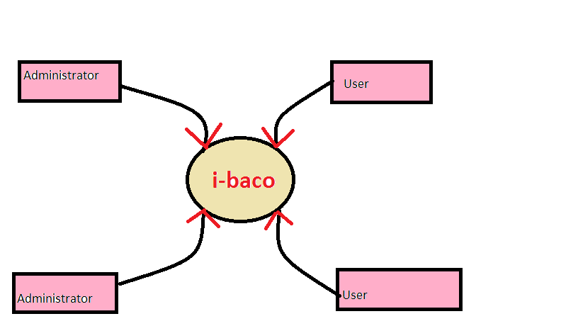

LEVEL 1

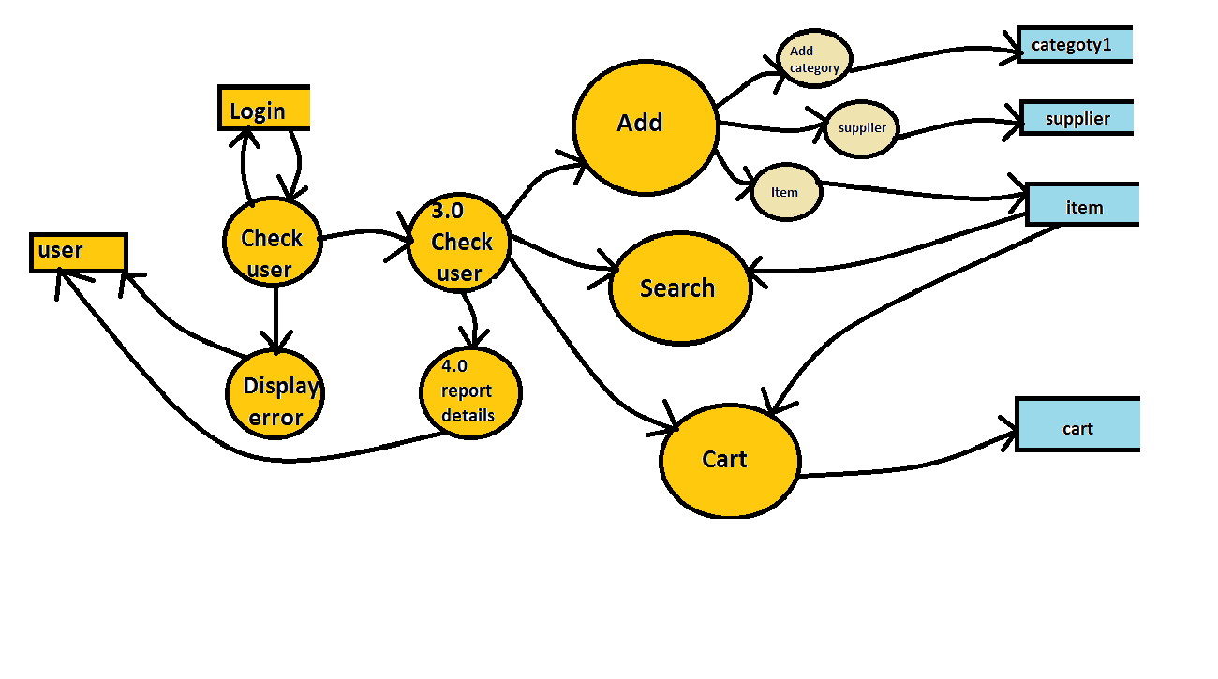

7.3 SCREEN LAYOUT

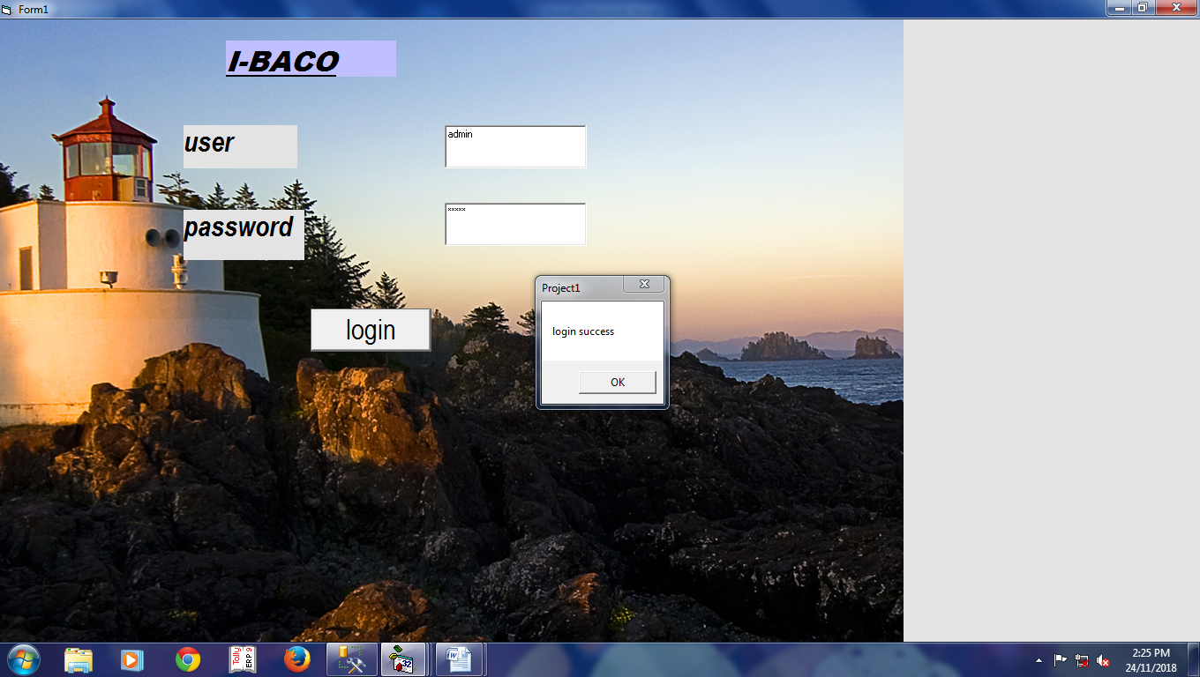



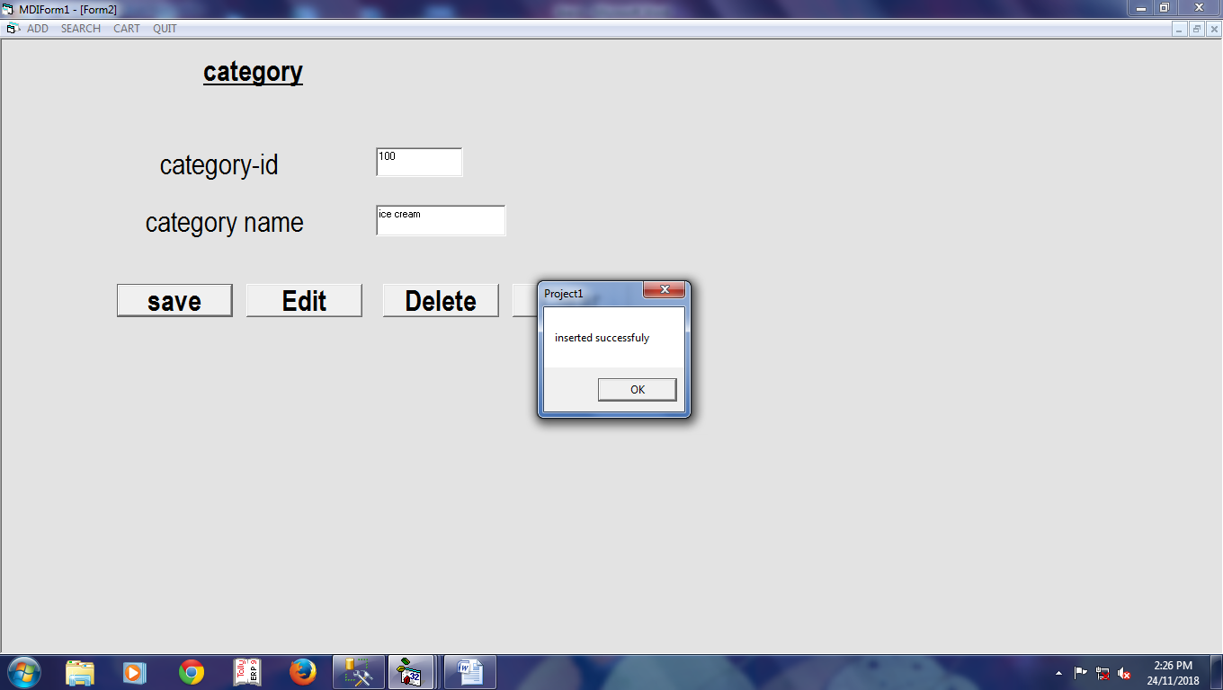

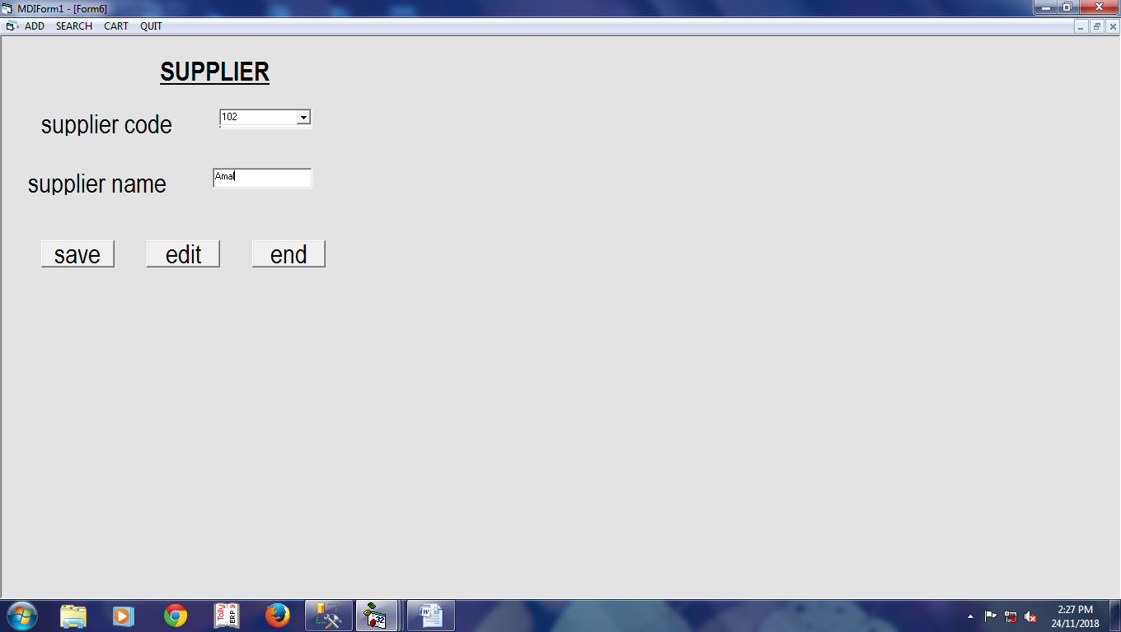

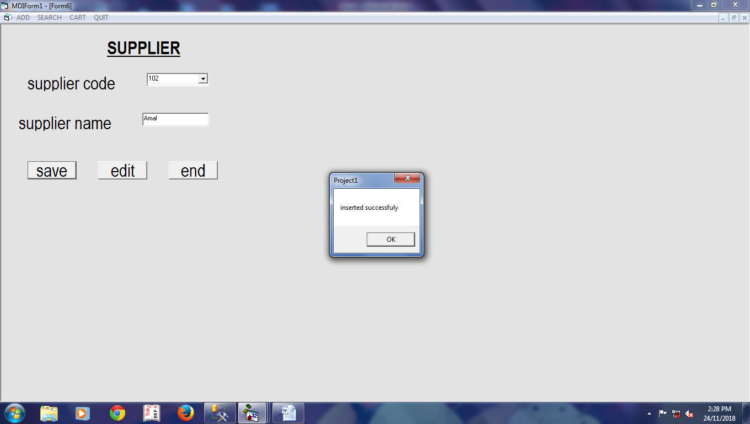

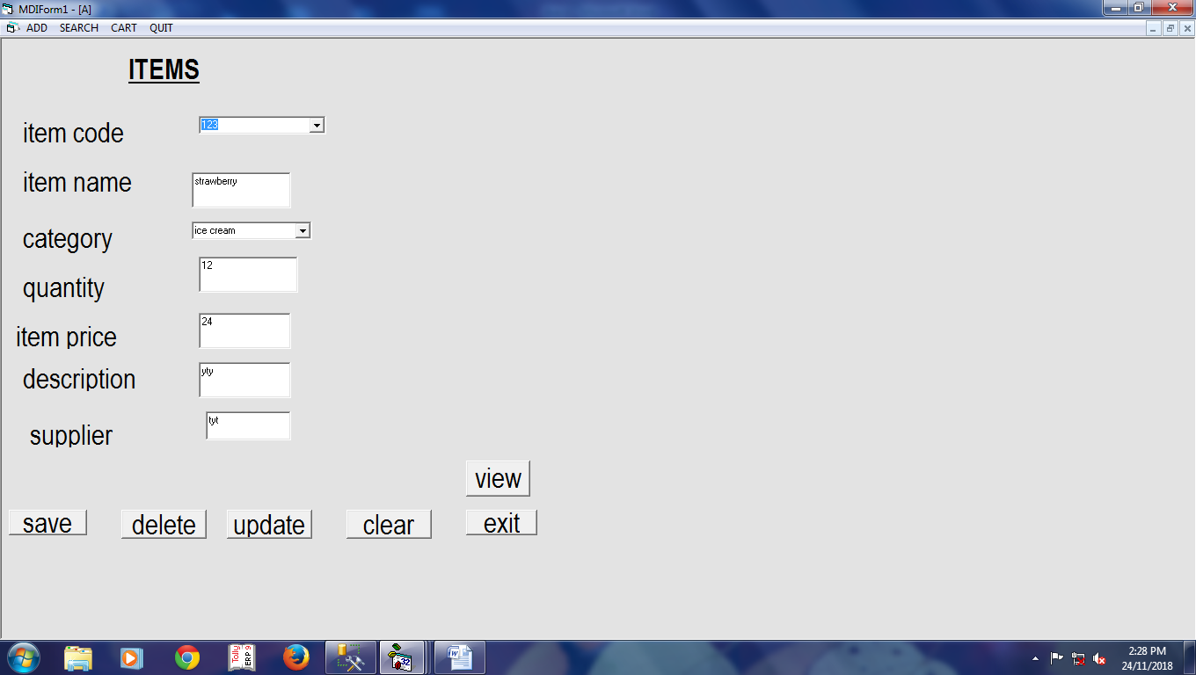
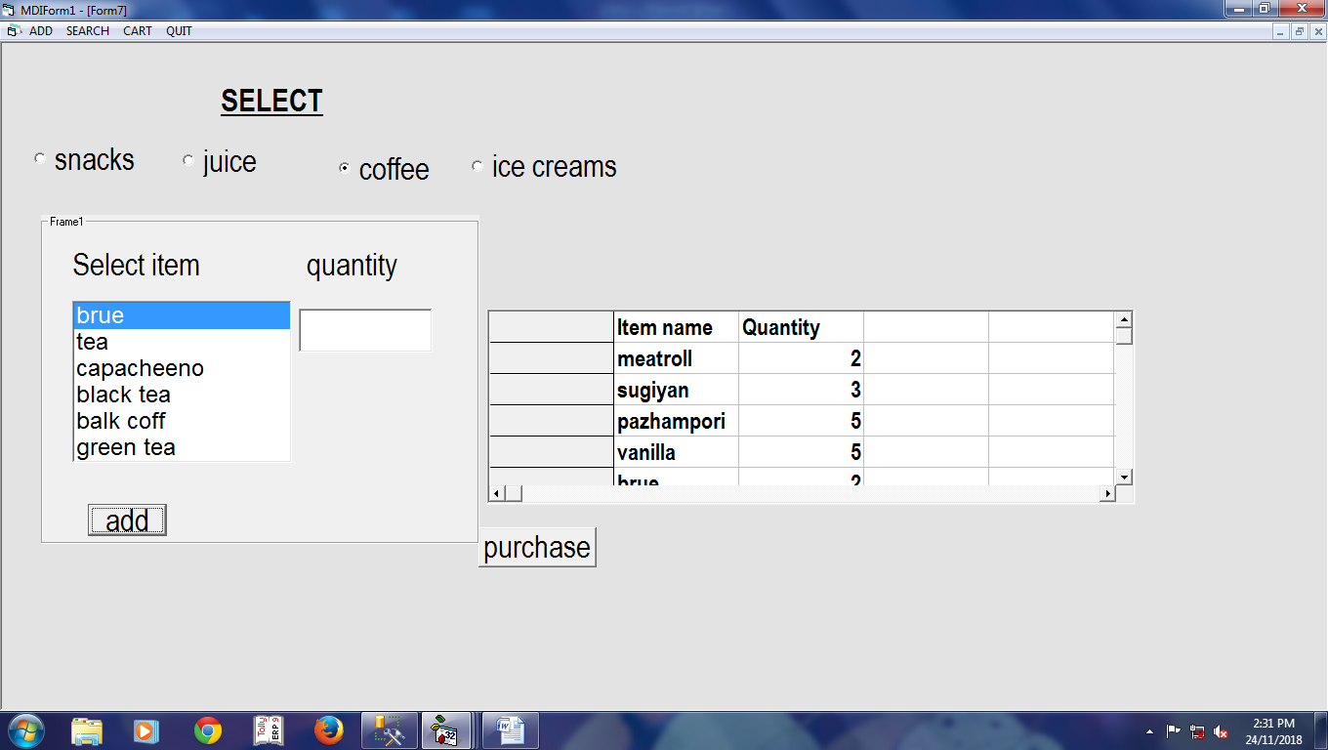

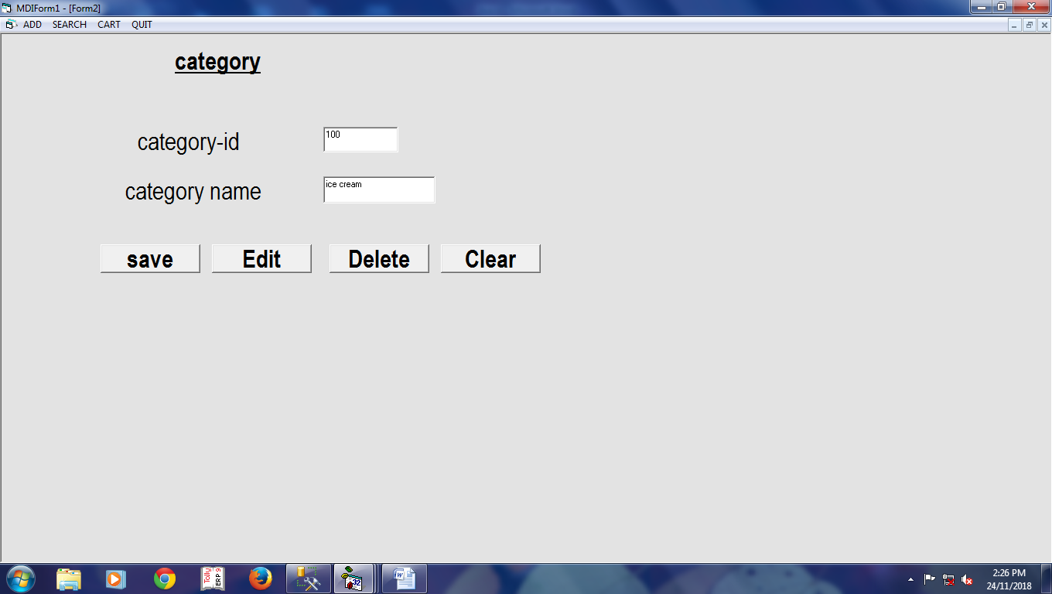

7.4 PROGRAM CODE
login
Dim utype As String
Dim un As String
Dim pw As String
Dim flag As String

Private Sub Command1_Click()
If (Text1.Text = "") Then
Label4.Visible = True
Else
Label4.Visible = False
End If
If (Text2.Text = "") Then
Label5.Visible = True
Else
Label5.Visible = False
End If
If (Text1.Text <> "" And Text2.Text <> "") Then
un = Text1.Text
pw = Text2.Text
flag = 0
sql = "select * from login"
db_selectdata (sql)
While (Not db_rset.EOF)
If (un = db_rset(0) And pw = db_rset(1)) Then
flag = 1
End If
db_rset.MoveNext
Wend
If flag = 1 Then
MsgBox "login success"
MDIForm1.Show
Unload Me
Else
MsgBox "invalid login credentials"
End If
End If
End Sub

Category

Private Sub Combo1_Click()
sql = "select * from category1 where category_id=" & Combo1.Text
db_selectdata (sql)
If Not db_rset.EOF Then
Text1.Text = db_rset(1)
End If
Command2.Caption = "Update"
End Sub
Private Sub Command1_Click()
sql = "insert into category1 values(" & Text2.Text & ",'" & Text1.Text & "')"
db_createcommand (sql)
MsgBox ("inserted successfuly")
End Sub

Private Sub Command2_Click()
sql = "select category_id from category1"
db_selectdata (sql)
While Not db_rset.EOF
Combo1.AddItem db_rset(0)
db_rset.MoveNext
Wend
Combo1.Visible = True
Text2.Visible = False
End Sub
Item
Private Sub Combo2_Click()
sql = "select * from item where itemcode=" & Combo2.Text
db_selectdata (sql)
If Not db_rset.EOF Then
Text2.Text = db_rset(1)
Combo1.Text = db_rset(2)
Text3.Text = db_rset(3)
Text4.Text = db_rset(4)
Text5.Text = db_rset(5)
Text6.Text = db_rset(6)
End If
Command1.Caption = "update"
End Sub

Private Sub Command1_Click()
If Command1.Caption = "edit" Then
sql = "select itemcode from item"
db_selectdata (sql)
While Not db_rset.EOF
Combo2.AddItem db_rset(0)
db_rset.MoveNext
Wend
Combo2.Visible = True
Text1.Visible = False
ElseIf (Command1.Caption = "update") Then
sql = "update item set itemname='" & Text2.Text & "',category= '" & Combo1.Text & " ',quantity=" & Text3.Text & ",itemprice=" & Text4.Text & ",description='" & Text5.Text & "',supplier='" & Text6.Text & "'where itemcode=" & Combo2.Text & " "
db_createcommand (sql)
MsgBox "updated successfully"
End If
End Sub

Private Sub Command4_Click()
Text1.Text = ""
Text2.Text = ""
Text3.Text = ""
Text4.Text = ""
Text5.Text = ""
Text6.Text = ""
Combo1.Text = ""
End Sub

Private Sub Command6_Click()
End
End Sub

Private Sub Command7_Click()
sql = "insert into item values(" & Text1.Text & ",'" & Text2.Text & "','" & Combo1.Text & "'," & Text3.Text & "," & Text4.Text & ",'" & Text5.Text & "','" & Text6.Text & "')"
db_createcommand (sql)
MsgBox ("inserted successfuly")
End Sub

Private Sub Form_Load()
sql = "select * from category1"
db_selectdata sql
While Not db_rset.EOF
Combo1.AddItem db_rset(1)
db_rset.MoveNext
Wend
End Sub
Supplier
Private Sub Combo1_Click()
sql = "select * from supplier where supplier_code=" & Combo1.Text
db_selectdata (sql)
If Not db_rset.EOF Then
Text1.Text = db_rset(0)
Text2.Text = db_rset(1)
End If
Command2.Caption = "update"
End Sub
Private Sub Command1_Click()
sql = "insert into supplier values('" & Text1.Text & "','" & Text2.Text & "')"
db_createcommand (sql)
MsgBox ("inserted successfuly")
End Sub

Private Sub Command2_Click()
sql = "select supplier_code from supplier"
db_selectdata (sql)
While Not db_rset.EOF
Combo1.AddItem db_rset(0)
db_rset.MoveNext
Wend
Combo1.Visible = True
Text1.Visible = False
End Sub
Selection
Dim ctry As String
Dim i As Integer

Private Sub Command1_Click()
MSFlexGrid1.Rows = MSFlexGrid1.Rows + 1
MSFlexGrid1.TextMatrix(i, 1) = List1.Text
MSFlexGrid1.TextMatrix(i, 2) = Text1.Text
Text1.Text = ""
i = i + 1
End Sub
Private Sub Command2_Click()
End Sub

Private Sub Form_Load()
If Option1.Value = True Then
ctry = "Snacks"
End If
If Option2.Value = True Then
ctry = "Juice"
End If

If Option4.Value = True Then
ctry = "ice cream"
End If
i = 1
MSFlexGrid1.TextMatrix(0, 1) = "Item name"
MSFlexGrid1.TextMatrix(0, 2) = "Quantity"
End Sub

Private Sub Option1_Click()
ctry = "Snacks"
List1.Clear

sql = "select * from item where category ='" & ctry & "'"
db_selectdata (sql)
While (Not db_rset.EOF)
List1.AddItem (db_rset(1))
db_rset.MoveNext
Wend
End Sub

Private Sub Option2_Click()
ctry = "Juice"
List1.Clear

sql = "select * from item where category ='" & ctry & "'"
db_selectdata (sql)
While (Not db_rset.EOF)
List1.AddItem (db_rset(1))
db_rset.MoveNext
Wend
End Sub
Private Sub Option3_Click()
ctry = "coffie"
List1.Clear
sql = "select * from item where category ='" & ctry & "'"
db_selectdata (sql)
While (Not db_rset.EOF)
List1.AddItem (db_rset(1))
db_rset.MoveNext
Wend
End Sub

Private Sub Option4_Click()
ctry = "ice cream"
List1.Clear
sql = "select * from item where category ='" & ctry & "'"
db_selectdata (sql)
While (Not db_rset.EOF)
List1.AddItem (db_rset(1))
db_rset.MoveNext
Wend
End Sub

Cart
Private Sub Command1_Click()
Text4.Text = Val(Text2.Text) * Val(Text3.Text)
sql = "insert into cart values('" & Text1.Text & "'," & Text2.Text & "," & Text3.Text & "," & Text4.Text & ")"
db_createcommand (sql)
MsgBox ("inserted successfuly")
End Sub

CHAPTER 8
BIBLIOGRAPHY
8. 1 Web Resources
- http://www.articles.techrepublic.com
- http://www.wikipedia.org
- http://www.exforsys.com
- http://www.google.com

8. 2 Book References
- Mastering Visual C# .NET by Jason Price , TMH Publications
- Microsoft SQL Server Black Book by Patrick Dalton, Prentic Hall Publications
- Software Engineering and Application by Rogger S. Pressman, TMH Publications.

